- list all the main components you find inside a desktop PC after opening the cabinet, and write a short description (1-2 lines) for each.
ANS:
Component | Description
Motherboard | Connects all computer parts.
CPU | Processes all instructions.
CPU Cooler | Keeps the CPU cool.
RAM | Stores temporary data.
HDD/SSD | Stores files and Windows.
SMPS (Power Supply) | Supplies power to all components.
GPU (Graphics Card) | Handles graphics and gaming.
Cooling Fan | Cools the PC components.
CMOS Battery | Saves BIOS settings and time.
SATA Cables | Connect storage devices.
Expansion Cards | Add extra features to the PC.
- Take clear photos or draw labeled diagrams of each step as you disassemble a desktop PC, and organize them in a document with captions explaining what you did at each step.<br><br><em><strong>Hint:</strong> Include steps like unplugging power, removing side panel, disconnecting cables, and removing RAM, HDD/SSD, and motherboard.</em>
ANS:
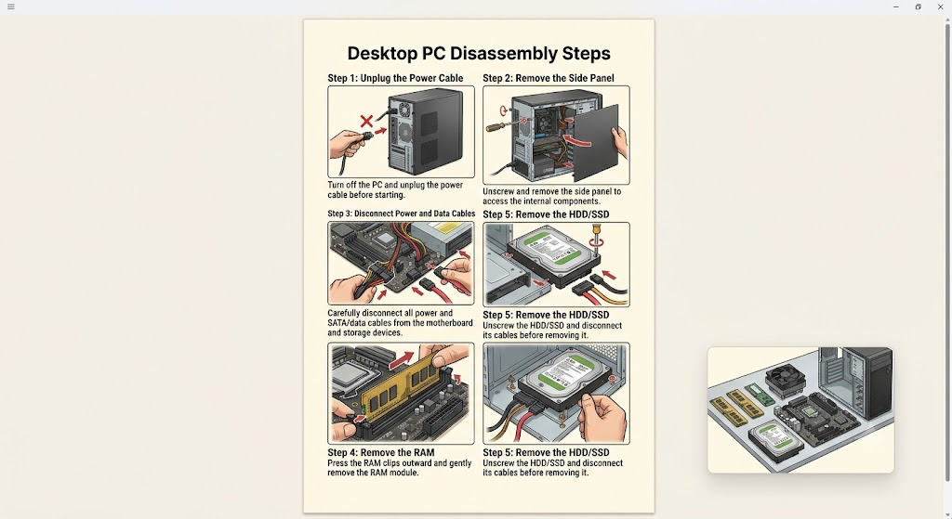

- Reassemble the PC you disassembled, documenting each step with a brief explanation of what you connected or installed and why the order matters.
ANS:
PC Reassembly Steps
- Install Motherboard – Fix it inside the cabinet.
- Install CPU & Cooler – Place CPU and attach the cooler.
- Install RAM – Insert RAM into the slot.
- Install HDD/SSD – Fix the storage drive.
- Connect Cables – Connect power and SATA cables.
- Install GPU (if available) – Insert the graphics card.
- Close Side Panel – Tighten the screws.
- Power On – Start the PC and check it works.

- Create a checklist of safety precautions and tools needed before starting the PC assembly/disassembly process, and explain why each is important.
ANS:
Safety Precautions & Tools Checklist
Item | Why Important
Turn off PC | Prevents electric shock.
Unplug Power Cable | Ensures safety before opening the PC.
Phillips Screwdriver | Used to remove and tighten screws.
Anti-static Wrist Strap | Protects components from static electricity.
Clean Workspace | Prevents damage and loss of parts.
Keep Screws Safe | Avoids losing small screws.
Handle Parts Carefully | Prevents damage to components.
Do Not Force Components | Prevents breaking connectors or slots.

